**Supporting Information**

**Biomimicking Hydrophobic Leaf Structure using Soft Lithography for Fog Harvesting, Triboelectric Nanogenerators as a Self-Powered Rain Sensor**

Shaik Ruksana Beguma, Arunkumar Chandrasekhar a*

aNanosensors and Nanoenergy Lab, Sensor systems lab,

Department of Sensors and Biomedical Technology, School of Electronics Engineering,

Vellore Institute of Technology, Vellore, Tamilnadu, India

Corresponding author's Email:

*[arunkumar.c@vit.ac.in](mailto:arunkumar.c@vit.ac.in)

**Dr. Arunkumar Chandrasekhar**

Nanosensors and Nanoenergy Lab, Sensor systems lab,

Department of Sensors and Biomedical Technology, School of Electronics Engineering,

Vellore Institute of Technology, Vellore, Tamilnadu, India.

ORCID ID-https://orcid.org/0000-0002-4561-0975

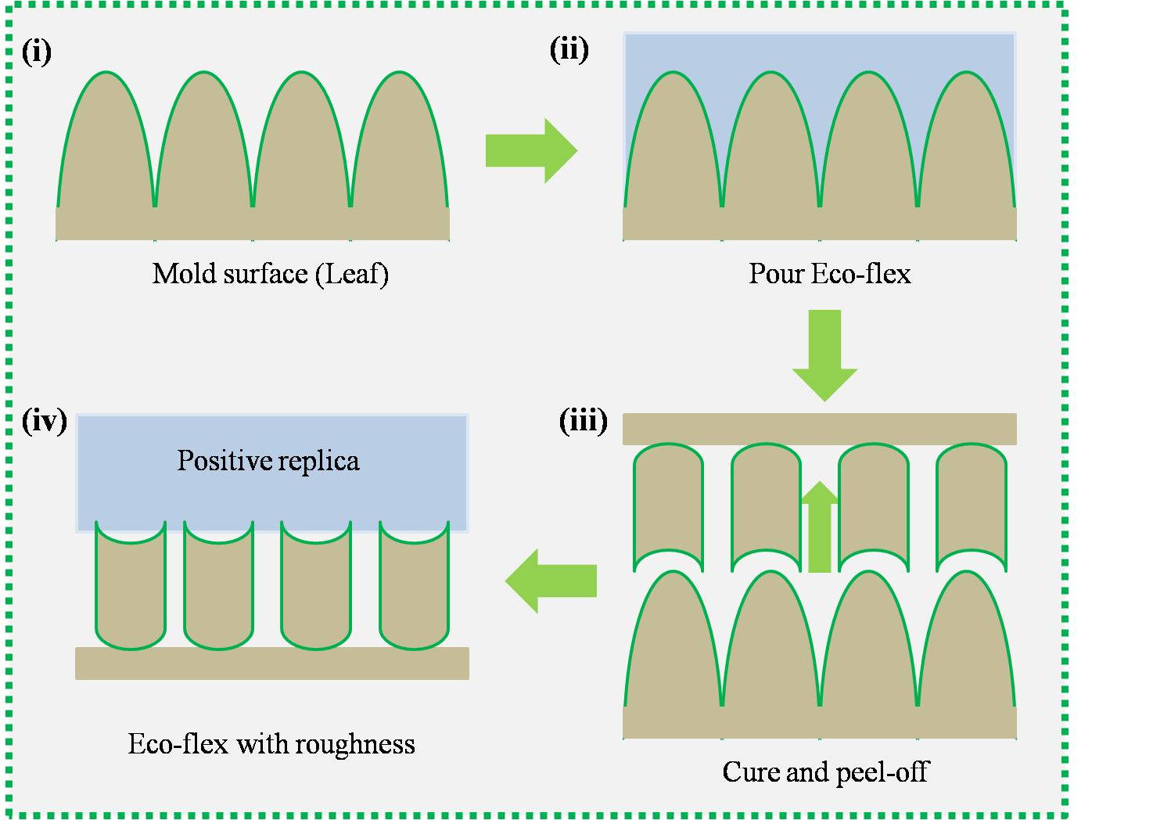

**Fig. S1.** A soft lithography oper1ation occurs on the surface of a leaf.

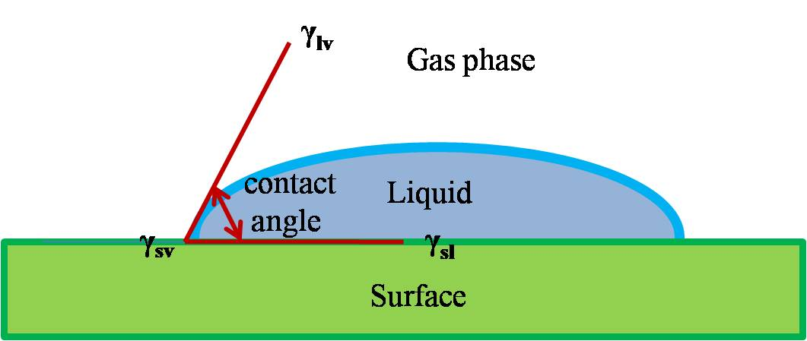

**Fig. S2.** Three-phase boundary contact angle and interfacial tension.

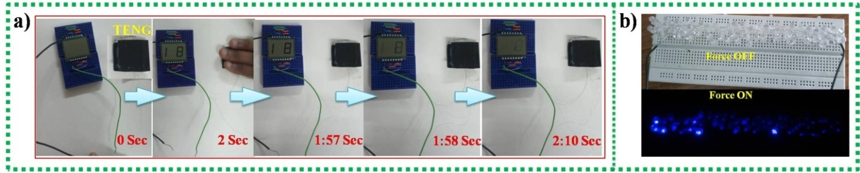

**Fig. S3.** Leaf-TENG real-time applications: Powering (a) Lumex display, and (b) Series connected LEDs.

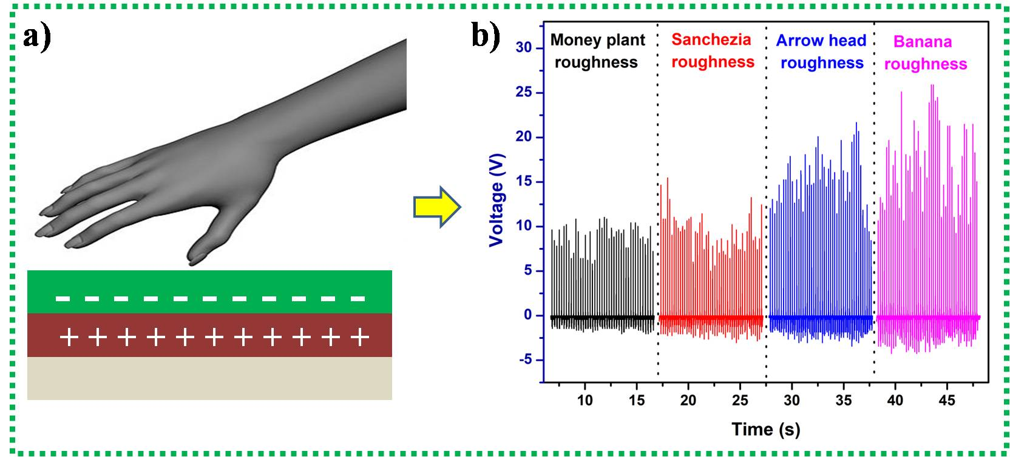

**Fig. S4.** (a) Single electrode mode mechanism, (b) Open circuit voltage corresponding to the applied force.

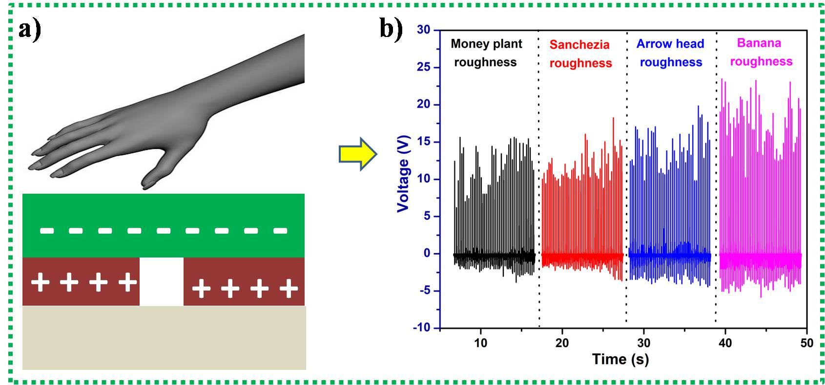

**Fig. S5.** (a) Freestanding triboelectric layer mechanism, (b) Open circuit voltage corresponding to the applied force.

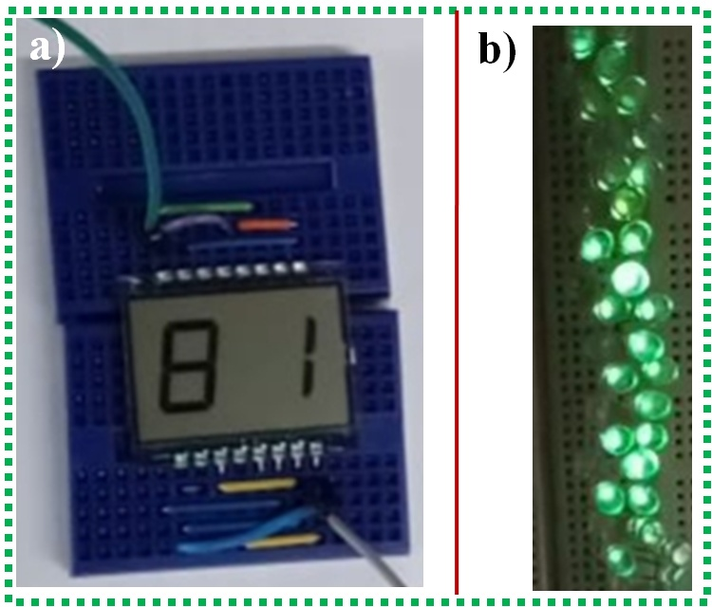

**Fig. S6: Real-time applications of TENG device using two modes: Powering (a) Lumex display, and (d) Series-connected LEDs**

Supporting Videos List:

1. Video S1:Powering Lumex display
2. Video S2:Powering series connected to 18 LEDs
3. Video S3:**Chess timer using Leaf-TENG**
4. Video S4: **Rain sensor TENG device using single electrode mode**
5. Video S5:Powering Lumex display for single electrode mode
6. Video S6:Powering series connected to 20 LEDs for single electrode mode